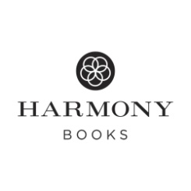
Effortless Healing
About the Book
LET YOUR BODY DO THE WORK
Do you have to tell your leg to heal from a scrape? Your lungs to take in air? Your body that it’s hungry? No. Your body does these things automatically, effortlessly. Vibrant health is your birthright and within your grasp; you just have to step out of the way. In Effortless Healing, online health pioneer, natural medicine advocate, and bestselling author Dr. Joseph Mercola reveals the nine simple secrets to a healthier, thinner you. The results are amazing and the steps can be as easy to implement as:
- Throwing ice cubes in your water to make it more “structured”
- Skipping breakfast, as it could be making you fat
- Eating up to 75 percent of your calories each day in fat for optimal health, reduction of heart disease, and cancer prevention
- Avoiding certain meat and fish, but enjoying butter
- Eating sauerkraut (and other fermented foods) to improve your immune system and your mood
- Walking barefoot outside to decrease system-wide inflammation (and because it just feels great)
- Enjoying a laugh: it’s as good for your blood vessels as fifteen minutes of exercise
Effortless Healing is the distillation of decades of Dr. Mercola’s experience and cutting-edge medical knowledge. With his wisdom and that of your body, you can optimize your health, your weight, and your life…effortlessly.
DR. JOSEPH MERCOLA is a passionate advocate of natural medicine, a wellness champion, and a visionary who has implemented much-needed changes to our current health care system. As a physician for twenty-five years, he treated thousands of patients at his wellness center outside of Chicago, and in 1997 he created Mercola.com, now the #1 natural health website in the world. A New York Times bestselling author, he has also appeared on national news media such as CNN, Fox News, ABC News, Today, CBS's Washington Unplugged, and The Dr. Oz Show.

Available February 24, 2015
9780553417975
$26 Hardcover

